##### A Project report on

**CRYPTOCURRENCY PRICE ANALYSIS WITH ARTIFICIAL INTELLIGENCE**

###### A Dissertation submitted to JNTU Hyderabad in partial fulfillment of the academic requirements for the award of the degree.

**Bachelor of Technology**

**in**

**Computer Science and Engineering**

Submitted by

**Batch - 86**

**19H51A05P6 – P.N.V.J. KIRAN**

**19H51A05N5 – K. VINAY BHARGAV**

**19H51A05N6 – K. JAI SANTHOSH BABU**

Under the esteemed guidance of

**Mr.J.Ranjith**

 Assistant Professor

**Department of Computer Science and Engineering**

**CMR COLLEGE OF ENGINEERING AND TECHNOLOGY**

(An Autonomous Institution under UGC & JNTUH, Approved by AICTE, Permanently Affiliated to JNTUH, Accredited by NBA.)

KANDLAKOYA, MEDCHAL ROAD, HYDERABAD - 501401.

#### 2019- 2023

**CMR COLLEGE OF ENGINEERING & TECHNOLOGY**

KANDLAKOYA, MEDCHAL ROAD, HYDERABAD – 501401

**DEPARTMENT OF COMPUTER SCIENCE AND ENGINEERING**

#### Logo New

#### CERTIFICATE

This is to certify that the Major Project Phase - 1 report entitled **“CRYPTOCURRENCY PRICE ANALYSIS WITH ARTIFICIAL INTELLIGENCE”** being submitted by **P.N.V.J. Kiran (19H51A05P6), K. Vinay Bhargav(19H51A05N5), K. Jai Santhosh Babu (19H51A05N6)** in partial fulfillment for the award of **Bachelor of Technology in Computer Science and Engineering** is a record of Bonafide work carried out his/her under my guidance and supervision.

The results embody in this project report have not been submitted to any other University or Institute for the award of any Degree.

**Mr.J.Ranjith Dr. Siva Skandha Sanagala**

**Asst.Professor** **Associate Professor and HOD**

**Dept. Of CSE Dept. of CSE**

**Acknowledgement**

With great pleasure I want to take this opportunity to express my heartfelt gratitude to all the people who helped in making this project work a grand success.

We are grateful to **Mr. J. Ranjith** Assistant Professor, Dept. of Computer Science and Engineering for his valuable technical suggestions and guidance during the execution of this project work.

We would like to thank **Dr. S. Siva Skandha Sanagala,** Head of the Department of Computer Science and Engineering, CMR College of Engineering and Technology, who is the major driving forces to complete my project work successfully.

We are very grateful to **Dr. Vijaya Kumar Koppula**, Dean-Academic, CMR College of Engineering and Technology, for his constant support and motivation in carrying out the project work successfully.

We are highly indebted to **Dr. V A Narayana,** Principal, CMR College of Engineering and Technology, for giving permission to carry out this project in a successful and fruitful way.

We would like to thank the Teaching & Non- teaching staff of Department of Computer Science and

Engineering for their co-operation.

We express our sincere thanks to **Dr. Ch. Gopal Reddy**, Secretary, CMR Group of Institutions, for

his continuous care.

Finally, we extend thanks to our parents who stood behind us at different stages of this project. We sincerely acknowledge and thank all those who gave support directly and indirectly in completion of this project work.

P.N.V.J.KIRAN (19H51A05P6)  
 K. VINAY BHARGAV (19H51A05N5)  
 K. JAI SANTHOSH BABU (19H51A05N6)

|  |  |  |  |  |
| --- | --- | --- | --- | --- |
| **CHAPTER**  **NO.** | **TITLE** | | | **PAGE NO.** |
|  | **LIST OF FIGURES** | | | 1 |
|  | **LIST OF TABLES** | | | 1 |
|  | **ABSTRACT** | | | 2 |
| **1** | **INTRODUCTION** | | | 3 |
|  | 1.1 | Problem Statement | | 4 |
|  | 1.2 | Research Objective | | 4 |
|  | 1.3 | Project Scope and Limitations | | 5 |
| **2** | **BACKGROUND WORK** | | | 6 |
|  | 2.1 | USING BITCOIN TRANSACTION GRAPH TO PREDICT THE PRICE OF BITCOIN | | 7 |
|  | 2.1.1 | Introduction | 7 |
|  | 2.1.2 | Merits, Demerits and Challenges | 7 |
|  | 2.1.3 | Implementation of Bitcoin Price Prediction | 8 |
|  | 2.2 | CRYPTOCURRENCY VALUE FORMATION | | 9 |
|  | 2.2.1 | Introduction | 9 |
|  | 2.2.2 | Merits, Demerits and Challenges | 9 |
|  | 2.2.3 | Implementation of cryptocurrency value formation | 10 |
| **3** | **RESULTS AND DISCUSSION** | | | 13 |
|  | 3.1 | Comparison of Existing Solutions | | 14 |
|  | 3.2 | Data Collection and Performance metrics | | 15 |
| **4** | **CONCLUSION** | | | 16 |
|  | 4.1 | Conclusion | | 17 |
| **5** | **REFERENCES** | | | 18-19 |

**TABLE OF CONTENTS**

## List of Figures

|  |  |  |
| --- | --- | --- |
| **FIGURENO.** | **TITLE** | **PAGE NO.** |
| Fig 1.1.1 | Problem Statement | 4 |
| Fig 1.3.1 | Project Scope | 5 |
| Fig 2.1.2.1 | BITCOIN PRICE PREDICTION | 7 |
| Fig 2.1.3.1 | Implementation of Bitcoin Price Prediction | 8 |
| Fig 2.2.2.1 | CRYPTOCURRENCY VALUE FORMATION | 9 |
| Fig 2.2.3.1 | Implementation of Cryptocurrency Value Formation | 10 |
| Fig 3.1.1 | Comparison of Existing Solutions | 14 |
| Fig 3.1.3 | 14 |
| Fig 3.1.4 | 14 |

## List of Tables

|  |  |  |
| --- | --- | --- |
| **TABLE NO.** | **TITLE** | **PAGE NO.** |
| 3.1.2 | Implementation of Cryptocurrency Value Formation | 13 |
| 3.2.1 | Data Collection and Performance metrics | 16 |
| 3.2.2 | Data Collection and Performance metrics | 16 |

**ABSTRACT**

Cryptocurrency is playing an increasingly important role in reshaping the financial system due to its growing popular appeal and merchant acceptance. While many people are making investments in Cryptocurrency, the dynamical features, uncertainty, the predictability of Cryptocurrency are still mostly unknown, which dramatically risk the investments. It is a matter to try to understand the factors that influence the value formation. In this study, we use advanced artificial intelligence frameworks of fully connected Artificial Neural Network (ANN) and Long Short-Term Memory (LSTM) Recurrent Neural Network to analyze the price dynamics of Bitcoin, Ethereum, and Ripple. We find that ANN tends to rely more on long-term history while LSTM tends to rely more on short-term dynamics, which indicate the efficiency of LSTM to utilize useful information hidden in historical memory is stronger than ANN. However, given enough historical information ANN can achieve a similar accuracy, compared with LSTM. This study provides a unique demonstration that Cryptocurrency market price is predictable. However, the explanation of the predictability could vary depending on the nature of the involved machine-learning model.

**CHAPTER 1**

**INTRODUCTION**

**CHAPTER 1**

# **INTRODUCTION**

**1.1 Problem Statement:**

Cryptocurrency is the peer-to-peer digital moneywort and payment system that exist online via a controlled algorithm. When a miner cracks an algorithm to record a block of transactions to public ledger named blockchain and the cryptocurrency is created when the block is added to the blockchain. It allows people to store and transfer through encryption protocol and distributed network. Mining is a necessary and competitive component of the cryptocurrency system. The miner with more computational power has a better chance of finding a new coin than that of less. Bitcoin is the first and one of the leading digital currencies (its market capitalization had more than $ 7 billion in 2014, and then it increased significantly to $ 29 billion in 2017) which was first introduced by Satoshi Nakamoto in 2008. Among many features of bitcoin, the most impressive one is decentralization that it can remove the involvement of traditional financial sectors and monetary authorities effectively due to its blockchain network features In addition, the electronic payment system of Bitcoin is based on cryptographic proof rather than the trust between each other as its transaction history cannot be changed unless redoing all proof of work of all blockchain, which play a critical role of being a trust intermediary and this can be widely used in reality such as recording charitable contribution to avoid corruption. Moreover, bitcoin has introduced the controllable anonymity scheme, and this enhances users’ safety and anonymity by using this technology, for instance, we can take advantage of this property of blockchain to make identification cards, and it not only can protect our privacy but verify our identity. Nowadays, investing in cryptocurrencies, like Bitcoin, is one of the efficient ways of earning money

**1.2 Research Objective**

Cryptocurrency, such as Bitcoin, has established itself as the leading role of decentralization. There are a large number of cryptocurrencies sprang up after Bitcoin such as Ethereum and Ripple. Because of the significant uncertainty in its prices, many people hold them as a means of speculation. Therefore, it is critically important to understand the internal features and predictability of those cryptocurrencies. In this study, we use two distinct artificial intelligence frameworks, namely, fully-connected Artificial Neural Network (ANN) and Long-Short-Term-Memory (LSTM) to analyze and predict the price dynamics of Bitcoin, Ethereum, and Ripple.

**1.3 Project Scope and Objectives:**

**Project Scope:**

Cryptocurrencies became a worldwide phenomenon during the talk that they are visiting to replace general currencies within the near future. Cryptocurrencies adoption continues to understand momentum partially due to the world’s progression towards a cashless society. A major pro of cryptocurrencies is that they are mainly decentralized. Many cryptocurrencies are controlled by the developers using it and those who have a significant amount of the coin or by a corporation to develop it before it’s released into the market. The fact that some people, nowadays, transact through electronic money continues to affirm suggestions that cryptocurrencies could be the currencies of the long term. However, it will take it slow before they find their way into the mainstream sector, so our project help people to predict Cryptocurrencies price before only so that people can make trade without losing their money. After that we can extend our project and make a platform for Cryptocurrencies Management system in which user can buy and sell the Cryptocurrencies and they can even do transaction.

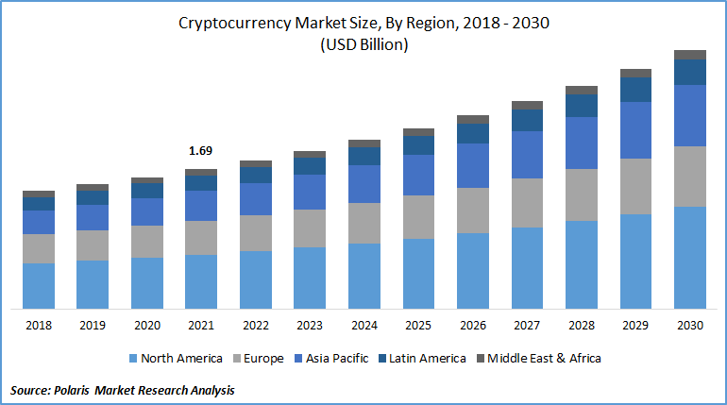

Fig 1.3.1

**Objectives:**

1. Cryptocurrency Price Analysis
2. Awareness in public about prediction dynamics
3. Long term investment
4. Reduces the risk of investment

**CHAPTER 2**

**BACKGROUND WORK**

**CHAPTER 2**

**BACKGROUND WORK**

**2.1 Using the Bitcoin Transaction Graph to Predict the Price of Bitcoin**

**2.1.1. Introduction**

* Our work builds on prior research to leverage blockchain network features, as a basis to conduct supervised machine learning prediction on the price of Bitcoin.
* Ron et. al used the Union-Find algorithm to group accounts belonging to the same individual or entity. their research showed that while the net flow of the graph far exceeds the number of Bitcoins in circulation, most Bitcoins are in fact not in circulation and 1 have not been moved or used since their mining.
* We compiled several network-based features to develop our supervised machine learning algorithms

**2.1.2. Merits, Demerits and Challenges**

**Merits:**

1. Predict the Price of Bitcoin
2. Perform better than other existing ones.

**Demerits:**

1. Not accurate.
2. Limited for bitcoin.
3. High Depends on Transaction.
4. Only few parameters are used.

**Challenges:**

1. Use Transaction Data
2. Make all problems satisfied.

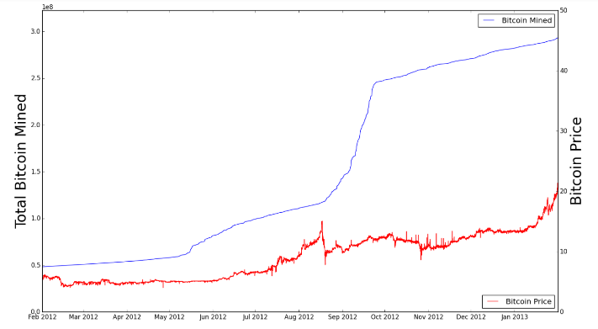**2.1.3.Implementation of BITCOIN PRICE PREDICTION**

2.1.4

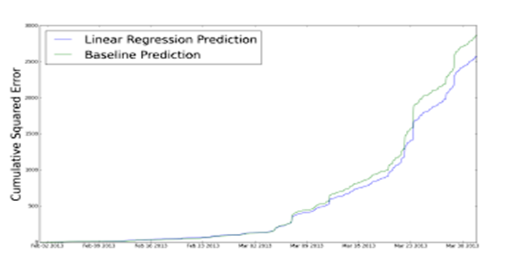

2.1.5

**Results:**

We leveraged several regression models to predict the price of Bitcoin one hour into the future, using our improved feature set. To set a baseline prediction, we chose a naive approach: we took the average percent price increase per hour (∼1%) and applied it to the current price to predict the price in an hour. We evaluated our performance by using mean squared error (MSE). Linear and SVM based regression we were able to predict price change better than baseline. we formulated the problem as a classification task. Best classifier was the 2-hidden-layer neural network.

**2.2 Cryptocurrency Value Formation: An Empirical Analysis Leading to a Cost of Production Model for Value Bitcoin**

**2.2.1. Introduction**

* This paper aims to identify the likely source(s) of value that cryptocurrencies exhibit in the marketplace using cross sectional empirical data examining 66 of the most used such 'coins’.
* A regression model was estimated that points to three main drivers of cryptocurrency value: the difficulty in 'mining 'for coins; the rate of unit production; and the cryptographic algorithm employed. The resulting regression model can be used to better understand the drivers of relative value observed in the emergent area of cryptocurrencies.
* Using the above analysis, a cost of production model is proposed for valuing bitcoin, where the primary input is electricity. This theoretical model produces useful results for both an individual producer, by setting breakeven points to start and stop production, and for the bitcoin exchange rate on a macro level. Bitcoin production seems to resemble a competitive commodity market; in theory miners will produce until their marginal costs equal their marginal product.

**2.2.2. Merits, Demerits and Challenges**

**Merits:**

1. Making increase accuracy.
2. Use Mining Data
3. Implementation done by using Mining values.

**Demerits:**

1. Predict only for bitcoin.
2. Not robust.
3. It is not so accurate.
4. Not predict Ethereum and ripple.

**Challenges:**

1. Need more fastest.
2. All the character classes should be involved.

**2.2.3. Implementation of Cryptocurrency Value Formation**

* In this bitcoin is used as generic example to explain the more general case of cryptocurrencies.
* few fundamental variables have been hard-wired into the Bitcoin protocol at its inception.
* ln(PRICE)=-9.68***+0.67∙ln(GH/s)**–0.98∙ln(COINS_PER_MIN)***– 0.57∙COINS_MINED + 7.43∙ALGO*** + 0.00067∙ DAYS_SINCE
* where: ln(PRICE) is the natural logarithm of the bitcoin-denominated market price on September 18, 2014.
* ln(GH/s) is the natural logarithm of the computational power in Giga Hashes per second.
* ln(COINS_PER_MIN) is the natural logarithm of the number of coins found per minute, on average which is computed by dividing Block Reward and Time Between Blocks.
* %COINS_MINED is the percentage of coins that have been mined thus far compared to the total that can ever be found.
* 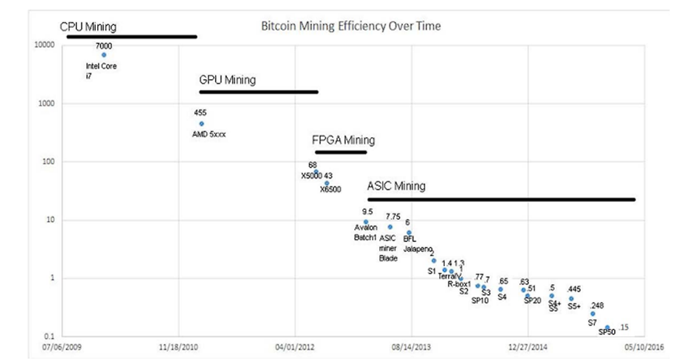 ALGO is a dummy variable for which algorithm is employed, taking on the value of '0' if SHA-256 and '1' if script.

2.2.4

**Results:**

Beginning with a cross-sectional analysis to define the causes of relative value formation amongst cryptocurrencies, it was found that relative differences in costs of production on the margin are the main determinants. By looking at bitcoin-denominated relative prices, which are available on a number of online cryptocurrency exchanges, the high degree of price volatility found in the dollar-bitcoin exchange rate was eliminated. Cross-sectional analysis also was able to remove a number of other issues found in time-series analysis including any chance of non-stationary data or a small-time horizon for the data set.

**CHAPTER 3**

**RESULTS AND DISCUSSION**

**CHAPTER 3**

**RESULTS AND DISCUSSION**

**3.1. Comparison of Existing Solutions:**

The first existing model contain data which contains every Bitcoin transaction made prior to April 7, 2013. All transactions are available on a public ledger, and this data set is a large text file containing a line for every transaction. Each line includes the transaction id, sender, recipient, value (in BTC), and a timestamp. Transactions involving multiple senders and multiple receivers are represented by multiple lines with the same transaction ID.   
  
The second existing model is a regression model was estimated that points to three main drivers of cryptocurrency value: the difficulty in 'mining 'for coins; the rate of unit production; and the cryptographic algorithm employed. The resulting regression model can be used to better understand the drivers of relative value observed in the emergent area of cryptocurrencies

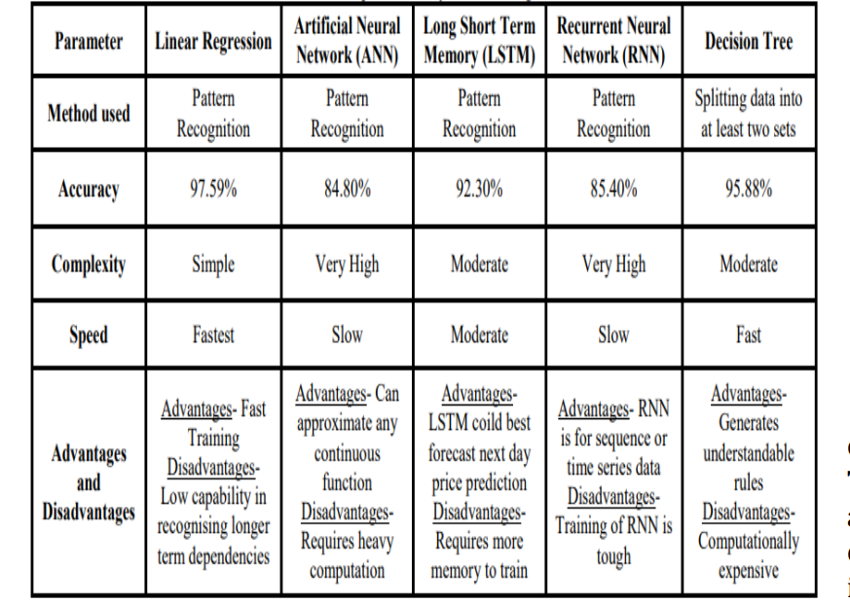Out the two existing solutions that are implemented above: Every solution has its own feature. The solution using the Bitcoin Transaction graph leverages several regression models to predict the price of Bitcoin one hour into the future. out of which the neural network model has highest accuracy and the later one , used the following Computation power in Giga Hashes per second, number of coins found per minute and the percentage of coins that have been mined thus far compared to the total that can be ever be found and derived a formula with which the price of the bitcoin is predicted. our price prediction solution uses the neural network, which has highest accuracy in the first existing solution with long short-term memory to predict the price of the bitcoin, Ethereum and ripple with almost accuracy

3.1.2

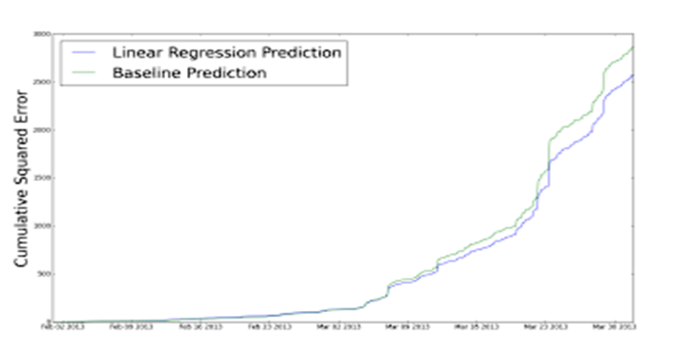

3.1.3

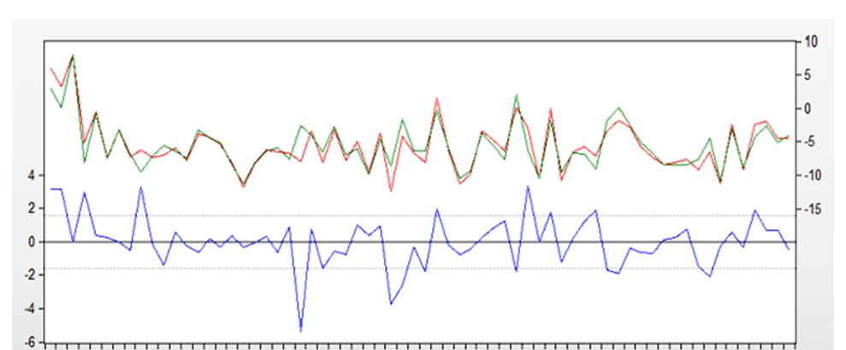

3.1.4

## 3.2 Data Collection and Performance metrics

## All transactions are available on a public ledger, and this data set is a large text file containing a line for every transaction. Each line includes the transaction id, sender, recipient, value (in BTC), and a timestamp. Transactions involving multiple senders and multiple receivers are represented by multiple lines with the same transaction id.

## 

## 3.2.1

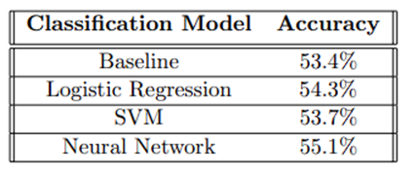

3.2.2

**CHAPTER 4**

**CONCLUSION**

## CHAPTER 4 CONCLUSION

**4.1 Conclusion**

Cryptocurrency, such as Bitcoin, has established itself as the leading role of decentralization. There are a large number of cryptocurrencies sprang up after Bitcoin such as Ethereum and Ripple. Because of the significant uncertainty in its prices, many people hold them as a means of speculation. Therefore, it is critically important to understand the internal features and predictability of those cryptocurrencies. In this study, we use two distinct artificial intelligence frameworks, namely, fully-connected Artificial Neural Network (ANN) and Long-Short-Term-Memory (LSTM) to analyze and predict the price dynamics of Bitcoin, Ethereum, and Ripple. We showed that the ANN and LSTM models are comparable and both reasonably well enough in price prediction, although the internal structures are different. Then we further analyze the influence of historical memory on model prediction. We find that ANN tends to rely more on long-term history while LSTM tends to rely more on short-term dynamics, which indicate the efficiency of LSTM to utilize useful information hidden in historical memory is stronger than ANN. However, given enough historical information ANN can achieve a similar accuracy, compared with LSTM. This study provides a unique demonstration that Cryptocurrency market price is predictable. However, the explanation of the predictability could vary depending on the nature of the involved machine-learning model.

**CHAPTER 5**

**REFERENCES**

**CHAPTER 5  
REFERENCES**

1. Greaves, A., & Au, B. (2015). Using the bitcoin transaction graph to predict the price of bitcoin. No Data.
2. Hayes, A. S. (2017). Cryptocurrency value formation: An empirical study leading to a cost of production model for valuing bitcoin. Telematics and Informatics, 34(7), 1308-1321.
3. Shah, D., & Zhang, K. (2014, September). Bayesian regression and Bitcoin. In Communication, Control, and Computing (Allerton), 2014 52nd Annual Allerton Conference on (pp. 409-414). IEEE.
4. Indra N I, Yassin I M, Zabidi A, Rizman Z I. Non-linear autoregressive with exogenous input (mrx) bitcoin price prediction model using so-optimized parameters and moving average technical indicators. J. Fundam. Appl. Sci., 2017, 9(3S), 791-808`
5. Adebiyi AA, Ayo C K, Adebiyi MO, Otokiti SO. Stock price prediction using a neural network with hybridized market indicators. Journal of Emerging Trends in Computing and Information Sciences, 2012, 3(1):1-9
6. Adebiyi AA, Ayo C K, Adebiyi MO, Otokiti SO. Stock price prediction using a neural network with hybridized market indicators. Journal of Emerging Trends in Computing and Information Sciences, 2012, 3(1):1-9
7. Ariyo AA, Adewumi AO, Ayo CK. Stock price prediction using the ARIMA model. In UKSim-AMSS 16th IEEE International Conference on Computer Modelling and Simulation (UKSim), 2014, pp. 106-112
8. Ron, D., & Shamir, A. (2013, April). Quantitative analysis of the full bitcoin transaction graph. In International Conference on Financial Cryptography and Data Security (pp. 6-24). Springer, Berlin, Heidelberg.
9. H. White, “Economic prediction using neural networks: The case of ibm daily stock returns,” in Neural Networks, 1988., IEEE International Conference on. IEEE, 1988, pp. 451–458
10. Kaastra and M. Boyd, “Designing a neural network for forecasting financial and economic time series,” Neurocomputing, vol. 10, no. 3, pp. 215–236, 1996. [11] H. White, “Economic prediction using neural networks: The case of ibm daily stock returns,” in Neural Networks,